Case Study (Medical Insurance) Project Documentation

Client: **XXX**

Project: Medical Insurance Case Study



Table of ContentS

Revision History 4

Overview 5

Functional Specification 8

System Workflow 9

Use Case CS-01 Register New User 11

Use Case CS-02 Create New Policy 12

Use Case CS-03 Request Proof of Insurance 13

Use Case CS-04 Raise Invoice for Medical Treatment 14

Use Case CS-05 Request Hospital Invoice 15

Use Case CS-07 Existing User Sign-In 16

DESCRIPTION OF THE SYSTEM COMPONENTS 17

Prototype Architecture 17

Data Storage: Hybrid Centralization and Self Sovereign 17

Acme Insurance 18

User Wallet 18

St Elsewhere Hospital 18

Architecture 20

Aries Architecture 20

CASE STUDY SYSTEM DESIGN 21

ACME User Interface 21

St. Elsewhere User Interface 22

Credential Revocation 24

Technology Stack 25

NodeJS 26

ReactJS – Material UI 26

ExpressJS 27

MongoDB 27

Trinsic API – Hyperledger Aries 27

REST API 27

Test Strategy 27

Testing Frameworks – Aries Test Harness, Jest/Enzyme, Selenium WebDriver, Android Tools 28

DEploYMENT Environment & ARCHITECTURE 29

Description of Deployment Architecture 29

Heroku Cloud Platform 29

Travis CI 30

GitHub 30

Code Branches and Deployment Environments 30

Sovrin Networks 30

METHODOLOGY / PLANNING 31

Prototype Phase 31

Prototype to Pilot to Production 31

DevOps 31

JIRA - Agile 32

Resources 32

User Documentation / Online Help 32

# Revision History

| Version | Date | Author | Change |
| --- | --- | --- | --- |
| 1.0 | September 1st | Mike Richardson | Initial Draft |

# Overview

This document describes a prototype application which allows customers to register with a fictional insurance company (Acme Insurance Company) and receive as a verifiable credential an insurance certification containing details of the insurance policy.

A fictional user, Alice, will be used throughout this document to describe the interactions between the user and the system

Additionally, there is a fictional hospital, St Elsewhere Hospital, which performs medical treatments and issues a medical certificate as a verifiable credential which the user (Alice) can then present to her insurance company in order to be reimbursed for the cost of the medical treatment.

We assume in this workflow that there is no direct connection between (or knowledge of) the issuers of credentials (Acme and St Elsewhere). Although that is a model used in certain countries where insurance costs are paid directly by the insurance companies to the hospital, we assume, for purposes of this case study and for reasons of simplicity, that the customer must meet the costs of medical treatment themselves and make an insurance claim later in order to be reimbursed.

This document is a combined Functional Specification / Technical Design. In reality these would most likely be separate documents. The Functional Specification has been written predominantly using Use Cases to outline how the system is to be modelled and to explain the workflow.

For purposes of the design and planning it is assumed we are building both insurance and hospital websites as the two deliverables of the project.

## Trust Over IP Stack

Governance Framework :

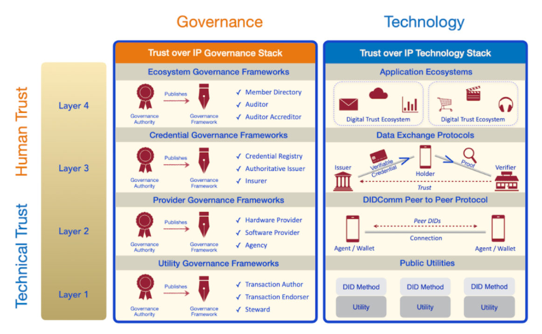

Figure 1 Trust Over IP Stack

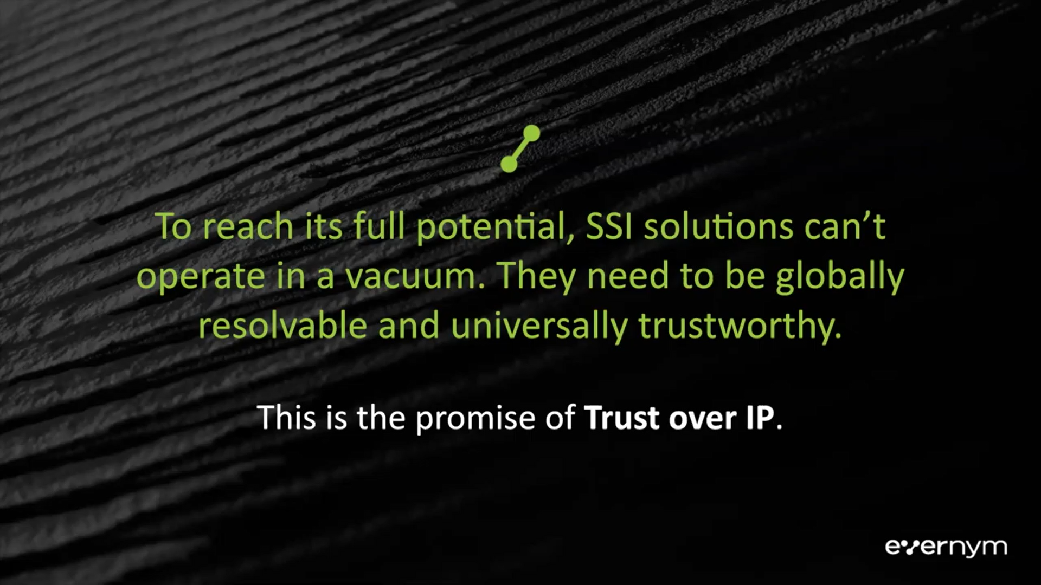

# Functional Specification

This section is our understanding of the system requirements, workflow and use cases.

The majority of the section is related to the use cases, as show in the following Use Case model:

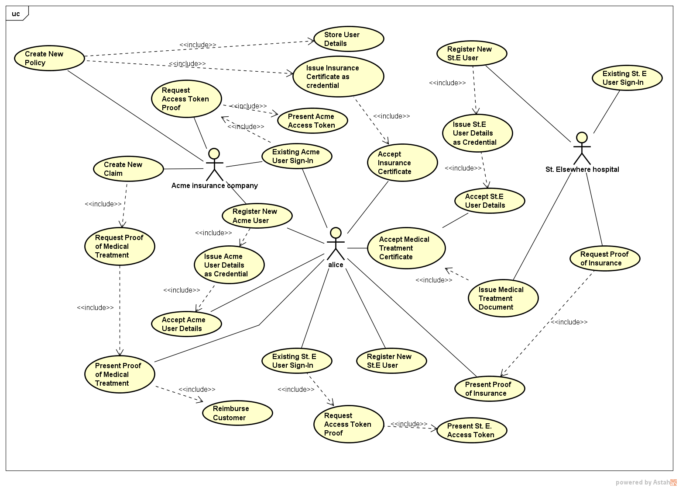

Figure 2 Use Case Model

## System Workflow

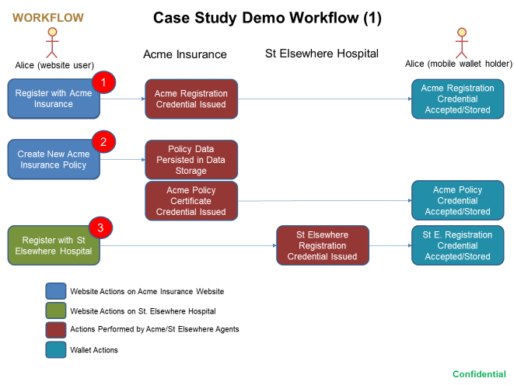

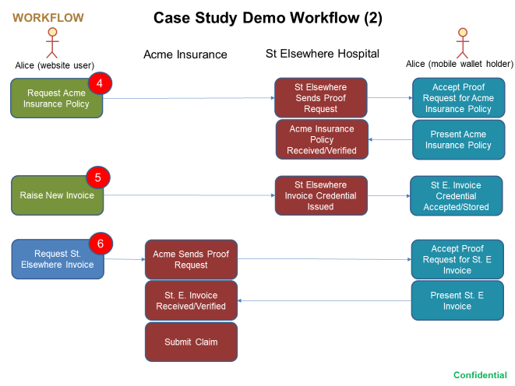

The above workflow shows the 6 main use cases covered in the Case Study.

The numbers in red circles refer to a particular Use Case, as described in the Use Case section below.

Note there are included (sub) use cases shown in the model and mentioned in the Use Cases themselves. These are not specified in this document.

1/3: CS-01 Register New User (for Acme or for St. Elsewhere)

2: CS-02 Create New Acme Insurance Policy

4: CS-03 Request Proof of Insurance

5: CS-04 Raise Invoice for Medical Treatment

6: CS-05 Request Medical Invoice

Also included is CS-06 Existing User Sign-In

Other Use Cases could be added as a Phase II Enhancements project to the initial set of Use Cases.

These include, but are not limited to, the following:

* Amend Insurance Policy
* Revoke and Reissue New Insurance Policy
* Cancel (Revoke) Insurance Policy
* Send Notification of Expiry of Insurance Policy
* Search for Policy
* Persist Claims and Issue Settled Claim Credential
* Display List of Claims
* Check Category of Insurance for Eligibility of Treatment

## Use Case CS-01 Register New User

|  |  |
| --- | --- |
| **Use Case ID:** | CS-01 |
| **Use Case Name:** | Register New User |
| **Business Actors:** | Alice, Acme Insurance, St Elsewhere Hospital |
| **Description:** | Alice registers as a new user and requests Acme or St Elsewhere to establish a connection |
| **Preconditions:** | Alice has mobile phone app installed |
| **Postconditions:** | Alice has connection record and registration credential in her wallet |
| **Basic Workflow:** | 1. Alice registers with Acme/St. Elsewhere by filling out following fields:   - First Name  - Last Name  - Email Address  - Country   1. Acme/St. Elsewhere displays QR Code 2. Alice scans QR code using phone app 3. Phone app displays an invitation asking Alice to connect 4. Alice accepts the invitation 5. Acme/St. Elsewhere issues credentials consisting of registration details to Alice including connection id 6. Alice accepts the credentials |
| **Alternative Workflow:** | 5a Alice may decline to accept the invitation  7a Alice may decline to accept the credential offer |
| **Exceptions:** | 1a Invalid value for any fields; error message displayed next to field to show the value is not valid |

## Use Case CS-02 Create New Policy

|  |  |
| --- | --- |
| **Use Case ID:** | CS-02 |
| **Use Case Name:** | Create New Policy |
| **Business Actors:** | Alice, Acme Insurance |
| **Description:** | Alice enters medical information into a form and creates a new insurance policy. Acme issues an insurance certificate as a verifiable credential. |
| **Preconditions:** | Alice has mobile phone app installed; Alice is a registered user and is logged in |
| **Postconditions:** | Alice has insurance policy persisted within Acme and an insurance certificate credential in her wallet |
| **Basic Workflow:** | 1. Alice creates a new policy filling out following fields:   - Smoker  - Drinker  - Age  - Illnesses  - Active  - Social Security Number   1. Acme generates a policy number 2. Acme persists the policy record to the MongoDB database 3. Acme issues an insurance certificate as a credential 4. Alice accepts the credential offer 5. Acme displays “revoke” as an option to revoke the policy instead of “issue” |
| **Alternative Workflow:** | 5a Alice may decline to accept the credential offer |
| **Exceptions:** | 1a Invalid value for any fields; error message displayed next to field to show the value is not valid  3a Database write fails: abort the process and display error message |

## Use Case CS-03 Request Proof of Insurance

|  |  |
| --- | --- |
| **Use Case ID:** | CS-03 |
| **Use Case Name:** | Request Proof of Insurance |
| **Business Actors:** | Alice, St. Elsewhere Hospital |
| **Description:** | Alice needs to have some medical treatment at hospital. In our Case Study we assume that the hospital needs to see Alice’s insurance policy before it will carry out the treatment. |
| **Preconditions:** | Alice has mobile phone app installed; Alice is a registered user of the hospital and has a medical insurance policy |
| **Postconditions:** | The hospital has verified the policy and can carry out the treatment (ideally, the hospital would check that this policy covers the type of treatment) |
| **Basic Workflow:** | 1. Alice instructs the hospital to execute a Proof Request from the hospital website 2. The hospital sends a Proof Request for Alice’s Insurance Policy to her phone 3. Alice receives and accepts the Proof Request 4. Alice’s mobile agent presents the Policy as a credential to the hospital 5. The hospital verifies that the Insurance Policy is correct |
| **Alternative Workflow:** | 4a Alice may decline to accept the Proof Request |
| **Exceptions:** |  |

## Use Case CS-04 Raise Invoice for Medical Treatment

|  |  |
| --- | --- |
| **Use Case ID:** | CS-010 |
| **Use Case Name:** | Raise Invoice for Medical Treatment |
| **Business Actors:** | Alice, St. Elsewhere Hospital |
| **Description:** | Once Alice’s has received her hospital treatment, the hospital raises an invoice. There are two possible models for paying medical costs:   1. Alice pays the bill, presents the invoice to the Insurance Company and is reimbursed 2. Alice presents the invoice to the Insurance Company who pay the hospital directly.   We assume for purposes of this Case Study that (i) is the case here. |
| **Preconditions:** | Alice has mobile phone app installed; Alice is a registered user of the hospital, has presented her insurance policy to the hospital and has received some medical treatment. |
| **Postconditions:** | The hospital has verified the policy and can carry out the treatment |
| **Basic Workflow:** | 1. Alice creates a new invoice which contains the following fields:   - Invoice Number (system generated)  - Hospital Name (system generated)  - Invoice Date (system generated)  - Insurance Policy Number (system generated)  - Amount (entered by User)  - Treatment Description (entered by User)   1. St Elsewhere persists the policy record to the MongoDB database 2. St. Elsewhere issues an invoice as a credential 3. Alice accepts the credential offer 4. St. Elsewhere displays “cancel” as an option to revoke the invoice instead of “issue” (in case of error) |
| **Alternative Workflow:** | 4a Alice may decline to accept the Proof Request |
| **Exceptions:** | If there is an error in the invoice it will need to revoked and reissued with the correct attributes. |

## Use Case CS-05 Request Hospital Invoice

|  |  |
| --- | --- |
| **Use Case ID:** | CS-05 |
| **Use Case Name:** | Request Hospital Invoice |
| **Business Actors:** | Alice, Acme |
| **Description:** | Alice needs to present the invoice created in Use Case 04 to Acme Insurance so that they can pay for the medical treatment |
| **Preconditions:** | Alice has mobile phone app installed; Alice is a registered user of Acme and has a medical insurance policy. She has received some medical treatment and has an invoice credential in her wallet |
| **Postconditions:** | Acme Insurance has verified the invoice and can now settle the outstanding amount for the cost of Alice’s treatment. |
| **Basic Workflow:** | 1. Alice instructs Acme to execute a Proof Request from the Acme website 2. Acme Insurance sends a Proof Request for Alice’s Insurance Policy to her mobile agent 3. Alice receives and accepts the Proof Request 4. Alice’s mobile agent presents the Invoice as a credential to Acme 5. Acme verifies that the Invoice is correct and reimburses Alice for the cost of treatment |
| **Alternative Workflow:** | 3a Alice may decline to accept the Proof Request |
| **Exceptions:** |  |

## Use Case CS-06 Existing User Sign-In

|  |  |
| --- | --- |
| **Use Case ID:** | CS-06 |
| **Use Case Name:** | Existing User Sign-In |
| **Business Actors:** | Alice, Acme Insurance, St Elsewhere Hospital |
| **Description:** | An existing user Alice wants to sign in to the website |
| **Preconditions:** | Alice has mobile phone app installed and is already registered as a user (has registration credential in her wallet) |
| **Postconditions:** | Alice is signed in to the system. Alice’s wallet name is displayed in the navbar (e.g. Alice-A50) |
| **Basic Workflow:** | 1. Alice clicks on the “Login” navbar link Acme/St. Elsewhere displays QR Code 2. Alice scans QR code using phone app 3. Phone App displays request for registration data 4. Alice accepts the request 5. Alice’s agent presents the registration data (including access token to the website 6. The website verifies the access token and logs Alice in |
| **Alternative Workflow:** |  |
| **Exceptions:** | 6a System cannot find connection data relating to the user: login attempt rejected with error message |

## DESCRIPTION OF THE SYSTEM COMPONENTS

## Prototype Architecture

### Data Storage: Hybrid Centralization and Self Sovereign

Both sides (Insurance and Hospital) are based on the same architecture (using ReactJS and Express with MongoDB for data persistence).

Self-Sovereign Identity is used for personal data and is not included as part of the records persisted to centralized data storage (in this way we anonymize the data). For example, insurance policy records are keyed on policy id which is also stored as an attribute of the insurance policy verifiable credential. In this way, if data queries return data sets where private data is required to augment the returned data set, those extra (private) attributes can be requested (as a proof request) from the user who has the data stored in her wallet.

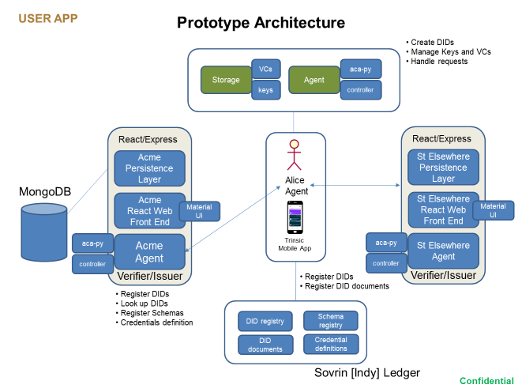

Figure 3 Prototype Architecture

## Acme Insurance

This is an example website which consists of three main components:

1. Persistence Layer. Some data records need to be persisted to a datastore for purposes of data analytics, reporting, querying etc. It is not efficient to do this using decentralized SSI “pods”. The records are anonymized in the sense that no attributes identifying the customer are stored in the centralized store. Personal data are stored in the credentials *Acme Registration.* We propose to use a NoSQL solution, i.e., *MongoDB*
2. Web Front End. The front end uses *ExpressJS* for server side middlewares and communications and *ReactJS* for the client side with a REST API operating between the two. ExpressJS has components for communicating with the persistent data store and the Aries Agent, and uses *Ngrok* for a tunneling service (in dev) which allows webhook events to be delivered to the server. Webhooks are used to listen for asynchronous events delivered by the Aries agent.

The prototype server code can be found in /insurance/server.js

The react front end code mainly resides in /insurance/src/App.js

1. Acme Agent. We propose using *Hyperledger Aries* as the off the shelf solution for self-sovereign identity. This provides the means to issue, verify and revoke credentials. Acme acts as issuer for insurance policies and verifier for invoices issued to/presented by the customer.

## User Wallet

We are using the *Trinsic* API and wallet for the Aries agent infrastructure. These provide a suitable infrastructure for prototyping and could be used in production as support is provided for using the wallet/agent with the Sovrin Main Net. The decision would have to be made as to whether a custom wallet would be preferable in the longer term, but this obviously would incur extra cost.

The wallet allows for agent communication using the DIDComm protocol; this is the standard protocol for Indy agents to communicate securely using a point-to-point connection.

## St Elsewhere Hospital

St Elsewhere Hospital is a fictional hospital at which our user Alice will be undertaking some medical procedure for which she needs to be reimbursed by her insurance policy. We assume, for purposes of this Case Study, that Alice has to pay for the medical procedure and then claim the cost back from the insurance company. For her to be able to do that, the hospital first requests confirmation of Alice’s insurance policy (which presumably the hospital uses to verify that Alice can go ahead with the treatment). Having already had her insurance policy issued to her as a credential she can present this to the hospital.

Once the treatment is done the hospital issues an invoice with the cost of treatment. This is stores in Alice’s wallet and would be used to claim the cost from the insurance company. See the Functional Specification for details of this workflow.

The hospital website consists of the same three main components as the Insurance company:

1. Persistence Layer. Some data records need to be persisted to a datastore for purposes of data analytics, reporting, querying etc. It is not efficient to do this using decentralized SSI “pods”. The records are anonymized in the sense that no attributes identifying the customer are stored in the centralized store. Personal data are stored in the credentials *St Elsewhere Registration.* We propose to use a NoSQL solution, i.e., *MongoDB*
2. Web Front End. The front end uses *ExpressJS* for server side middlewares and communications and *ReactJS* for the client side with a REST API operating between the two. ExpressJS has components for communicating with the persistent data store and the Aries Agent, and uses *Ngrok* for a tunneling service (in dev) which allows webhook events to be delivered to the server. Webhooks are used to listen for asynchronous events delivered by the Aries agent.

The prototype server code can be found in /hospital/server.js

The react front end code mainly resides in /hospital/src/App.js

1. St Elsewhere Agent. We propose using *Hyperledger Aries* as the off the shelf solution for self-sovereign identity. This provides the means to issue, verify and revoke credentials. Acme acts as issuer for insurance policies and verifier for invoices issued to/presented by the customer.

# Architecture

## Aries Architecture

The Aries architecture underlying the SSI system we use for this prototype is as follows:-

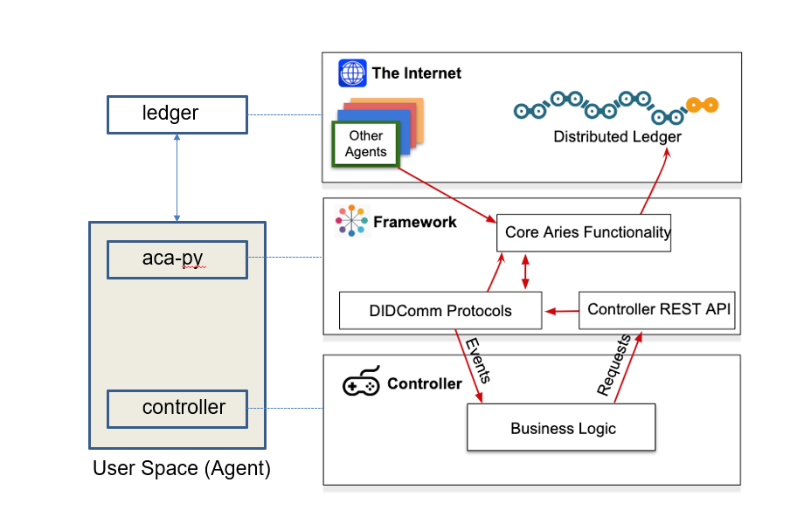

Figure 4 Aries Architecture

# CASE STUDY SYSTEM DESIGN

## ACME User Interface

The Acme website has two main tabs: New Policy and Enter Claim. New Policy allows users to enter medical information in order to create a new insurance policy. Once complete, the user can instruct the website to issue the policy certificate as a credential. The two tabs are shown below:

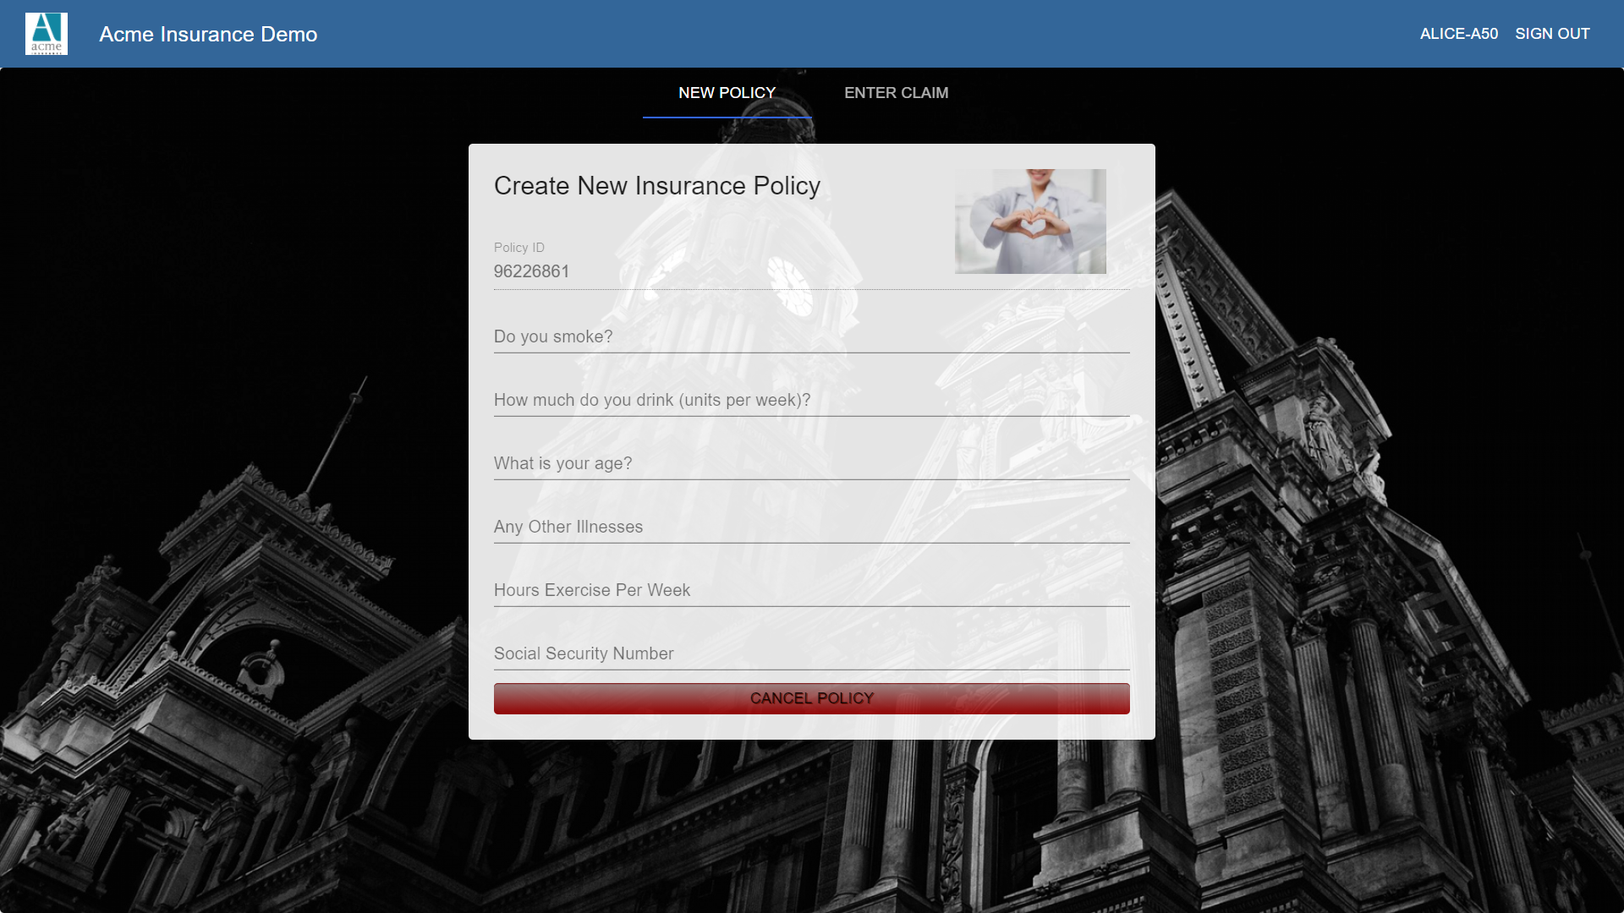

Figure 5 Acme “Create New Insurance Policy” screen

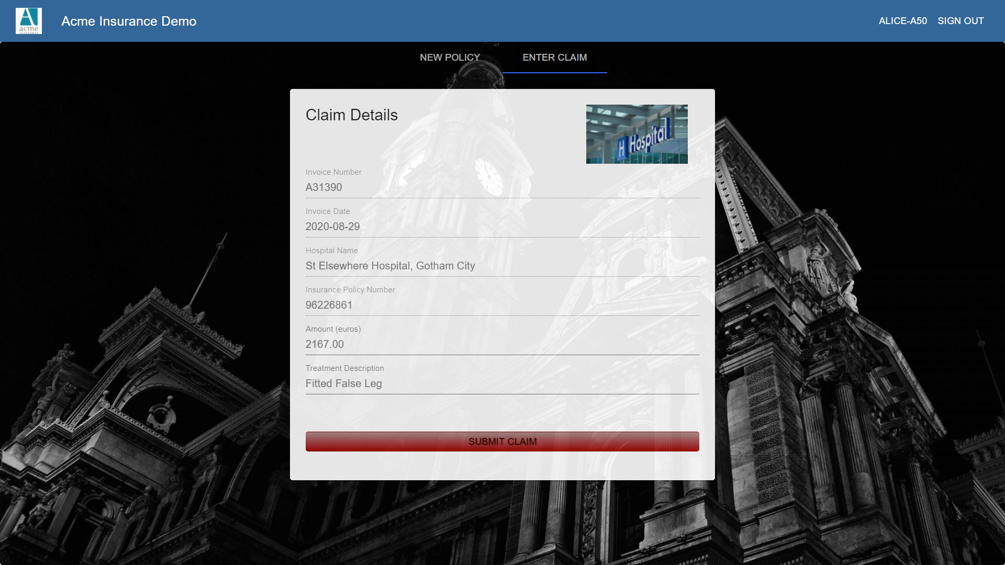

Figure 6 Acme “Submit Claim” screen

The User Interface consists of login/register links plus two tabs. For this Case Study, persisting of policy data, form field verification and user login have not been implemented. The intention would be to use a Proof Request to obtain the access token from the user registration credential as a means to restore the agent to agent connection that is established in the registration process, thus allowing “passwordless” website user authentication.

## St. Elsewhere User Interface

The St. Elsewhere hospital website contains two tabs: “Request Insurance Policy” and “Raise Invoice”. The tabs are shown below.

*Request Insurance Policy* instructs the hospital to send a proof request which is accepted and presented from the user’s mobile phone wallet.

*Raise Invoice* instructs the hospital to issue a credential containing details of the treatment carried out for use by the insurance company in settling medical costs.

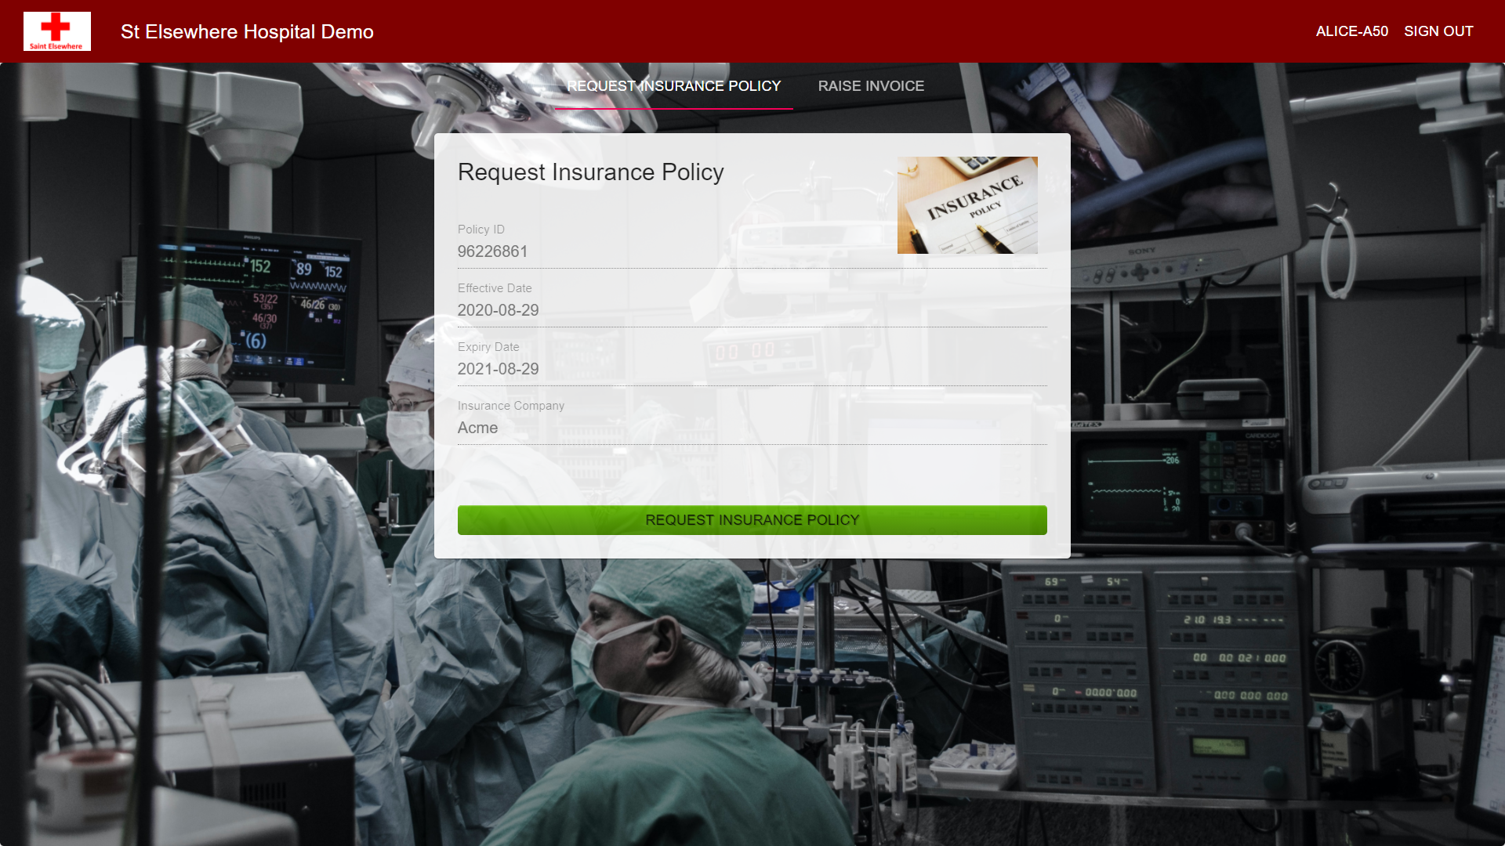

Figure 7 St. Elsewhere Request Insurance Policy Screen

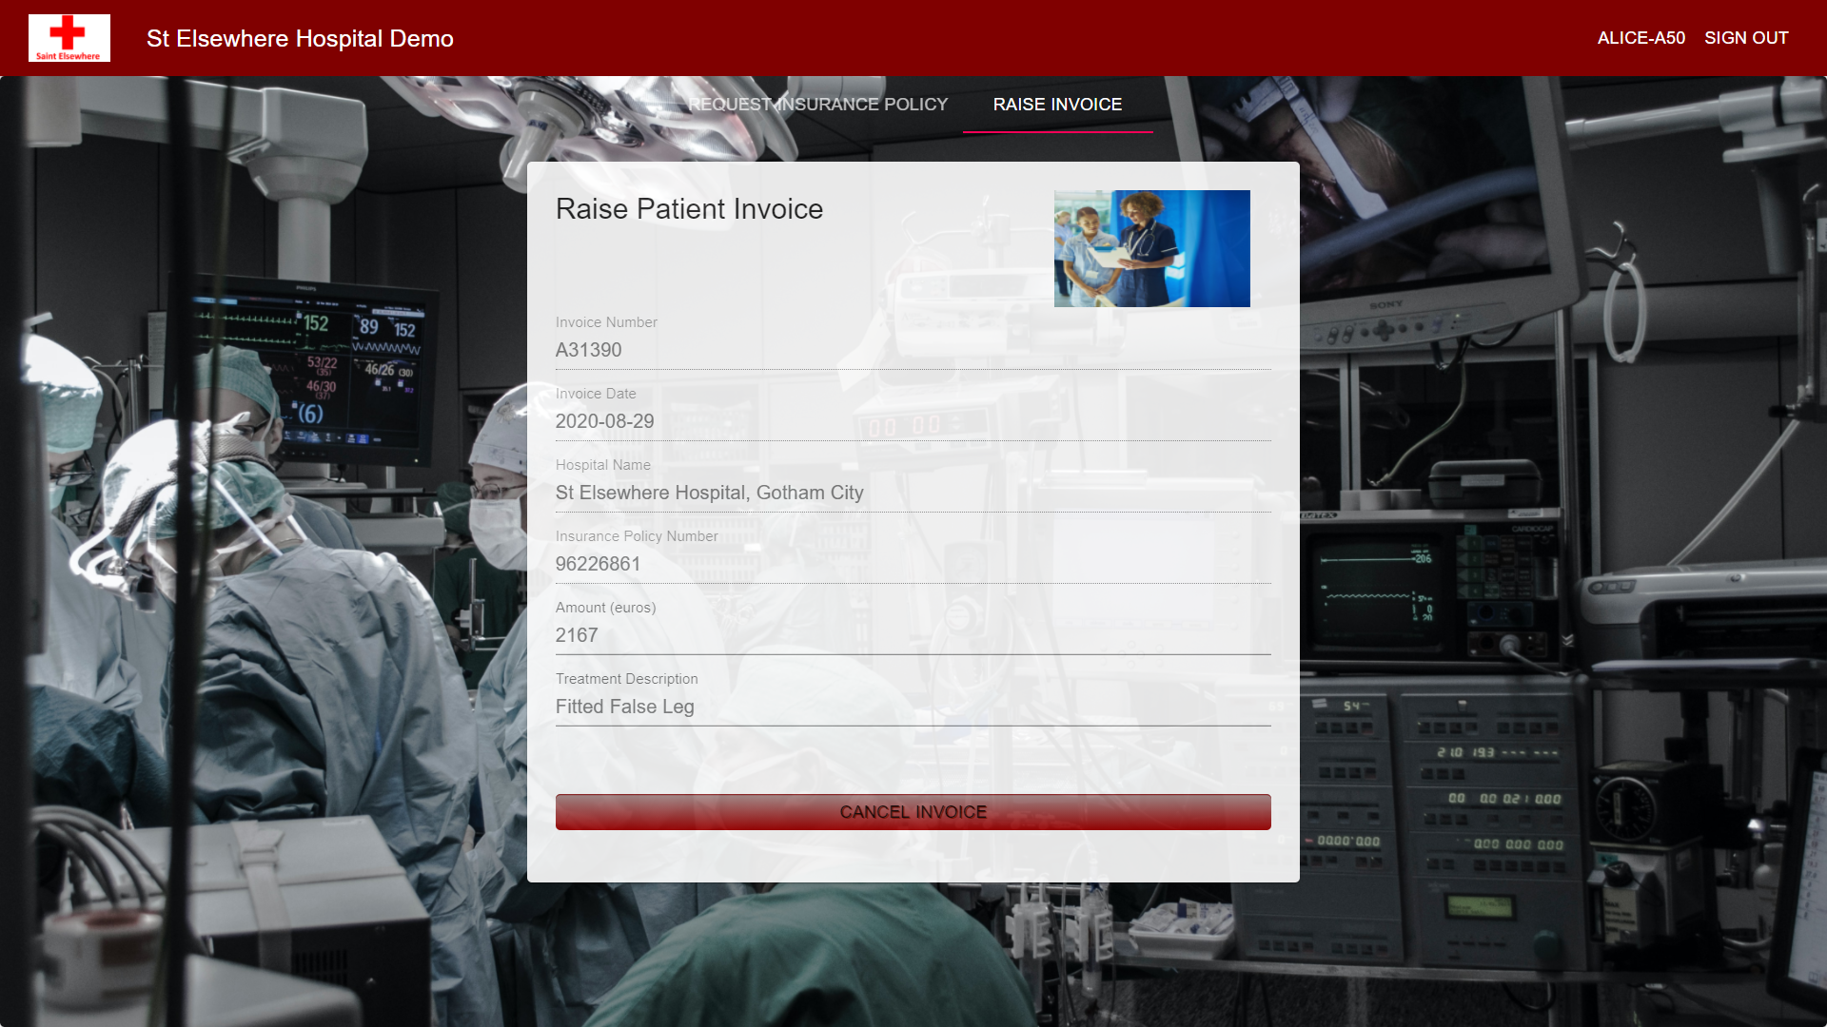

Figure 8 St. Elsewhere Raise Invoice Screen

## Credential Revocation

Credential revocations would be used in situations where the user wished to cancel a credential, e.g., cancel an insurance policy. This could happen because the user no longer wishes to be a customer or if some data have changed. Where credentials need to be updated, we must first revoke the existing credential and then issue a new one.

Where policy data are stored as database records it is imperative that we avoid “orphaned” data, for example where a database delete has failed but a credential revocation has succeeded. In this way we would end up with policy data but no certificate or the reverse.

Thus, we would need to ensure that database actions and credential actions are designed as single units of work. Where one part fails we would not execute the second, or roll back the entire transaction.

The solution would be to not commit a database transaction until the credential revocation has succeeded. If it fails the transaction can be rolled back.

## Technology Stack

The following two diagrams show a potential technology stack for building this system; the first shows the server-side tech stack (for the web server) and the second shows the front end tech stack.

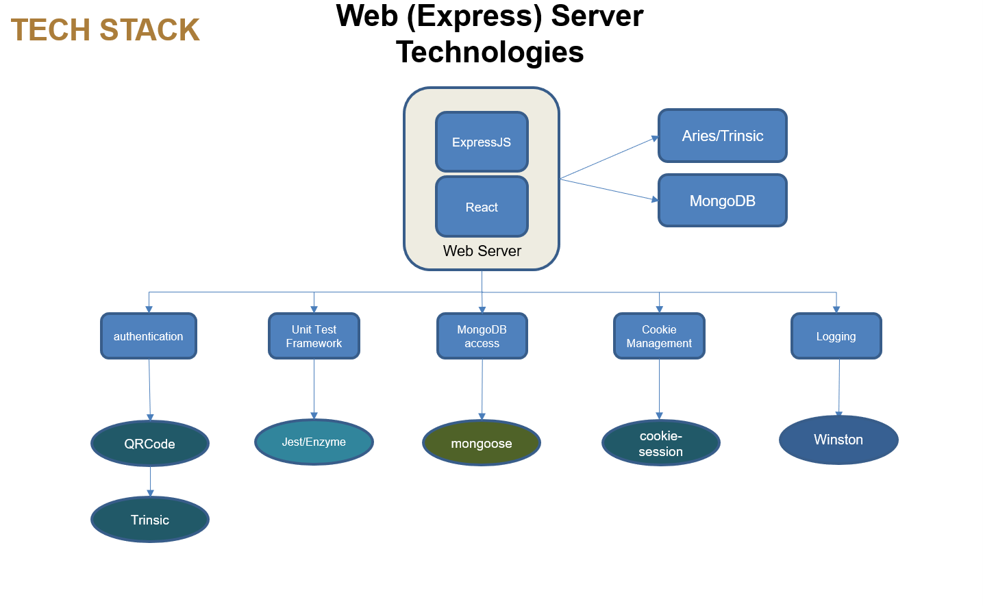

Figure 9 Web Server Tech Stack

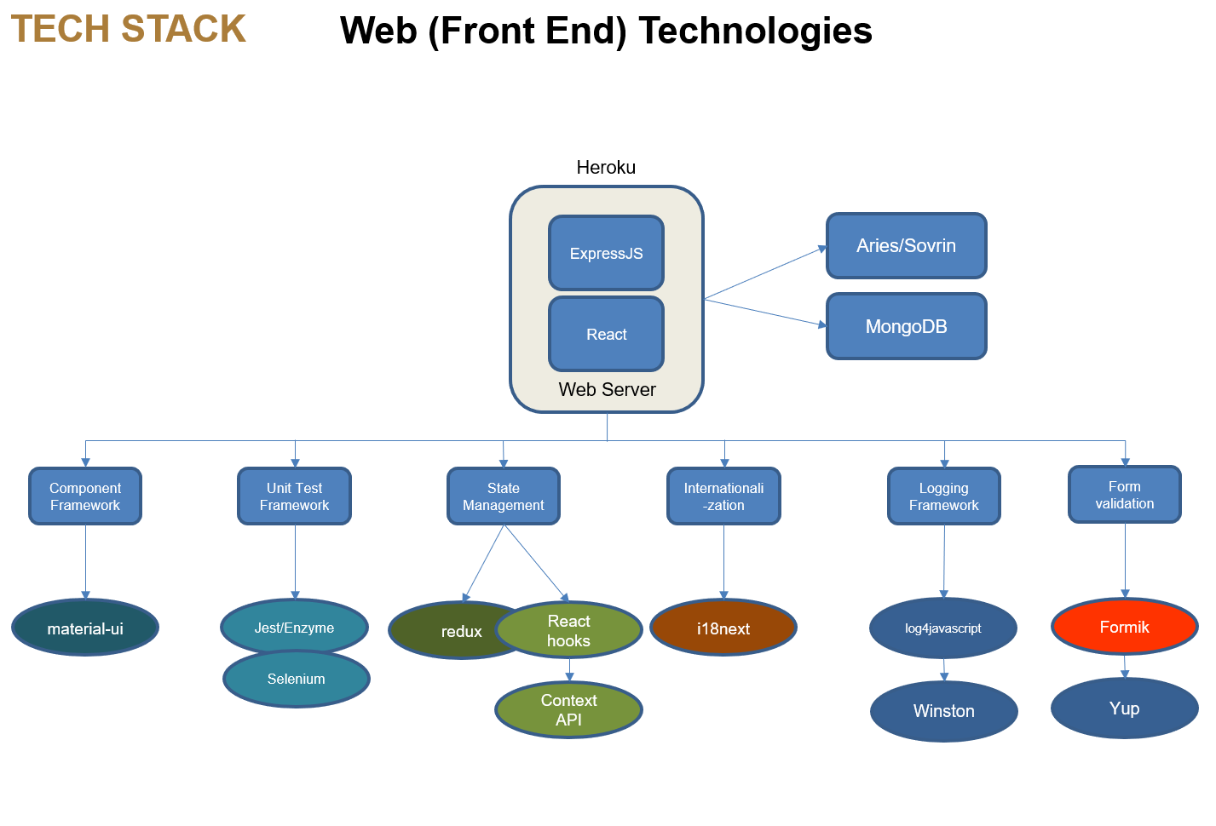

Figure 10 Client Tech Stack

### NodeJS

NodeJS should be used as our web development language of choice; there is a large and growing pool of expertise and many third-party tools and technologies available to facilitate development. Here are my recommendations for web technologies:

### ReactJS – Material UI

React has now superseded AngularJS as the front-end framework of choice and is the superior technology in my view. The new state handling with hooks greatly improves the framework and [almost] eliminates the need for redux state management.

MaterialUI and Bootstrap are competing component frameworks which both provide off-the-shelf React components for use in websites. I have doubts about form validation and the difficulty of styling MaterialUI components so further investigation should be carried out as to whether Bootstrap might be better.

### ExpressJS

ExpressJS is the server-side technology of choice. This demo has used it for listening to SSI (Aries) events coming in through webhooks and managing user choices to interact with the Trinsic API. There are many good ExpressJS plug in modules, for example *Mongoose* provides an excellent persistence framework for use with MongoDB database

### MongoDB

The hybrid solution recommended entails *anonymizing* personal data so that, although some user data is stored locally, it should be a) encrypted, and b) anonymous in the sense that no one can identify who the data belongs to.

Identification (Digital Identity) is handled by the use of verifiable credentials accessed via the user wallet.

The database of choice would be MongoDB as this [NoSQL] solution provides scalabilty and enhanced security features (such as encryption strategies).

MongoDB 3.2 provides a comprehensive encryption solution that protects user data, both in-flight and at-rest. For encryption-in-flight, MongoDB uses SSL/TLS, which ensures secure communication between the database and client, as well as inter-cluster traffic between nodes.

### Trinsic API – Hyperledger Aries

This project could be implemented using any of a number of blockchain technologies. We have become familiar with Hyperledger Indy/Aries and also the Trinsic suite of tools which facilitate not only prototyping and system design but also the Trinsic organisation provides support in areas such as setting up production networks which would be vital in trying to deploy robust, scalable solutions using what is still to some extend an immature technology (SSI)

### REST API

For development and testing of the Rest API which controls communications between the client and server we might consider building test tools using Swagger/OpenAPI.

## Test Strategy

As the project progresses I intend to increase the ratio of development – non-development staff by introducing a higher proportion of QA/Test engineers to the project. My view on this is that you can never do too much testing and we would require experts who can automate web testing and also provide test harnesses in areas such as performance, scalability and volume testing of the system, including testing of the load on the blockchain network.

### Testing Frameworks – Aries Test Harness, Jest/Enzyme, Selenium WebDriver, Android Tools

For UI testing I am not convinced of the worth of Jest/Enzyme. These tools usually seem to involve as much work mocking our JS libraries and in my view are not suitable for TDD development on the client side. For true automated testing on the client side, we are going to need to investigate automated tools for the mobile app.

Possibilities include tools such as *Robotium* and *UI Automator* for Android. For web front ends, I would use Selenium Web Driver (with scripts written in Java or Python). Running automated test suites saves a lot of time in QA/Black Box Testing by not having testers perform manual tests. We would need an experienced Test Engineer to work with us in crafting a suite of automated tests.

The Aries test harness for SSI is in its very early stages but shows a lot of promise. This could be used for automating SSI agent tests.

Jest/Enzyme are perfectly viable unit test tools for use with ExpressJS webserver applications.

# DEploYMENT Environment & ARCHITECTURE

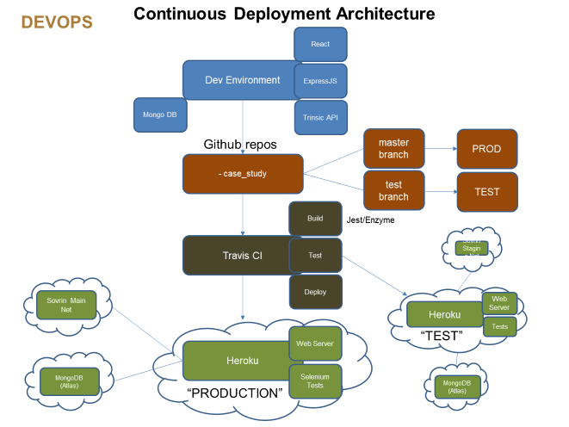

Figure 11 Case Study Deployment Architecture

## Description of Deployment Architecture

### Heroku Cloud Platform

Heroku is a cloud-based, fully managed platform as a service (Paas) for building, running, and managing apps

Part of the Heroku features is a web hosting service which provides similar cloud software services as AWS but has been found to be cheaper and simpler than an AWS solution. Therefore, we intend to use Heroku to host the any web server needed in the project.

Heroku can be configured to automatically deploy new software versions

### Travis CI

Travis CI is the Continuous Integration Server which automatically runs unit tests and package a build ready to be deployed by Heroku. Therefore, it can be integrated with the GitHub code repos and the downstream cloud platform, in this case Heroku.

### GitHub

Github is the choice for most modern software code repositories; a new repo has been created for the Case Study code. It can be found here:

<https://github.com/euroledger/case-study>

### Code Branches and Deployment Environments

As soon as is feasible we will have a master and test branch in Github. The master will be for deployment to production; test to the test environment. Test can receive new code as and when it is developed. Periodically this will be pushed to the master branch for deployment to production. Travis and Heroku can be configured to have separate environments and look for changes in the respective GitHub repos.

### Sovrin Networks

The Sovrin foundation provides two Hyperledger Indy-based ledger networks: the *Staging Network* and the *Main Network.*

The staging net is a free, public network which can be used for testing. We have been using this network throughout the phase I development process.

The Main Net is the main production Sovrin network. We will use this for the production blockchain. There is a fixed fee per credential definition/schema deployed then a small cost per transaction, these costs will be further evaluated in phase II.

# METHODOLOGY / PLANNING

The five main areas covered in the plan broadly fall into the following categories:

1. Analysis
2. Development
3. QA/Testing
4. Management
5. DevOps/Administration

## Prototype Phase

Initial project team would typically be top heavy with developers, often doubling up as business analysts:

1 x architect/dev

1 x fullstack developer

1 x Blockchain/SSI developer

Phase II/MVP Project Team up to production:

1 x business analyst

1 x QA/tester

1 x architect/dev

1 x fullstack developer

1 x Blockchain/SSI developer

1 x DevOps / system admin

1 x project manager

Post Production

In addition to sales teams etc. the make-up of the team would be the same as Phase II but with perhaps additional developers/testers (2 of each) responsible for maintenance and testing.

## Prototype to Pilot to Production

The initial prototype should be used to gauge customer feedback and to increase understanding of the domain. Once this is done, it feeds into the planning process (e.g. User Stories/Product Backlog) for the initial sprints.

## DevOps

Getting hold of good DevOps staff is crucial to enterprise software development. From as early a stage as possible we will package up code into Docker containers, we will use continuous integration (eg Travis CI) to run tests and deploy code and have test and prod environments.

We will need extensive scripts for database creation and maintenance, upgrade and rollback. We assume production servers will be running on Linux Cloud hosts.

## JIRA - Agile

* JIRA – 3-4 week sprints product backlog

## Resources

* Resources: PM/Scrum Master/Product Manager/Devs/BA/QA/DevOps

## User Documentation / Online Help

We would require a technical writer to produce extensive high-quality user documentation, possibly in multiple languages. This should be planned in from as early a stage as possible.

